|  |  |  |
| --- | --- | --- |
|  | **Assignment No. 1 Semester: Fall 2024**  **CS201 – Introduction to Programming** | **Total Marks: 20**  **Due Date: 7th Nov, 2024** |

**Instructions**

Please read the following instructions carefully before submitting the assignment solution:

It should be clear that your assignment will not get any credit/marks if:

* Assignment is submitted after the due date.
* Submitted assignments do not open or the file is corrupt.
* Assignment is copied (From internet/students).

**Recommended Tools**

* Dev C++

**Topic Covered**

* Loops
* Switch statements
* If/else statements

**Assignment Submission Instructions**

You must submit only the ".cpp” file of your code on the assignments interface from your LMS account.

*An assignment submitted in any other format will not be accepted and will be scaled with* ***zero marks****. No excuse will be accepted on submitting a solution file in any other format.*

For any query related to assignment, please contact [cs201@vu.edu.pk](mailto:cs201@vu.edu.pk).

**Problem Statement:**

Write a program that outputs your name and ID, checks if a year (derived by dropping the last two digits from right and then extract the next four digits from the numeric part of the studentID as explained below in step-by-step procedure) is a leap year or not, and then displays how many days there are in the month (take input from user).

**Note**: If the year is divisible by 4 and not divisible by 100 or divisible by 400, print that it is a leap year; otherwise, print that it is not a leap year.

**Step by step procedure:**

1. **Name and ID Output**:
   * The program should begin by outputting the student's name and VUID. Make sure the name and VUID are displayed at the very beginning of the output.
   * Store the numeric part of VUID in a variable name studentID.
2. **Leap Year Check**:
   * Instead of prompting the user for input, drop the last two digits from right and then extract the next four digits from the numeric part of the studentID and use it as the year to check whether it is a leap year.
   * See the following examples:
     1. For VUID bc123**4500**00, 4500 will be the year. You will drop the last two digits in the red and will take 4500 as year.
     2. For VUID bc231**2019**78, 2019 will be the year. You will drop the last two digits in the red and will take 2019 as year
     3. For VUID bc223**4891**24, 4891 will be the year. You will drop the last two digits in the red and will take 4891 as year
3. **Month Selection and Days Calculation**:
   * Take input from the user and determine the number of days, if month is invalid (i-e: not between 1 and 12) take appropriate action using if/else statement.
   * Use switch statements to determine how many days there are in that month. February should be handled differently for leap years (29 days) and non-leap years (28 days).

Note: Remember that if you have not used your name and student id in the program your marks will be deducted.

**Sample Output:1**

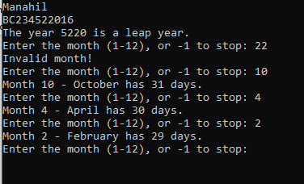

**Sample Output:2**

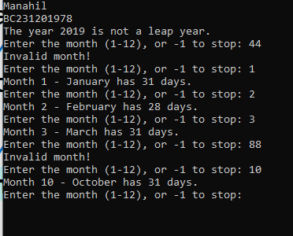

|  |
| --- |
| **Lectures Covered:** **Lecture # 1 - 8**  **Due Date:** **7th Nov, 2024** |